**Q1:**

I chose the SIR model. The SIR (susceptible-infectious-recovered) model consists of infectious agents who can transmit the pathogen to susceptible agents. Transmission may occur when infectious and susceptible agents come into contact. An infectious agent remains infectious for a finite amount of time. When the infectious period ends, the agent recovers. A recovered agent gains permanent immunity to the pathogen and cannot be reinfected.

**Q2:**

Statistics including:

1.percentage of infected individuals= infected people /total number of people*100

2.percentage of susceptible individuals= susceptible people/total number of people*100

3.percentage of recovered individuals= recovered people/total number of people *100

**Q3:**

New parameter: immunity-susceptible-rate

immunity-susceptible-rate is the rate that the recovered person may become susceptible again. It is the probability takes values randomly from 0 to 1 .

**Q4:**

In the netlogo, we have the new parameter that is the immunity-susceptible-rate for recovered people. It means they have the random chance to get susceptible again. What need to do is just add the following code in the go procedure and keep other codes the same as before.

ask turtles with [epi-state = recovered-code][

if random-float 1 < immunity-susceptible-rate [

set epi-state susceptible-code

set color blue

]

]

Explanation: We ask recovered people and “random-float 1 < immunity-susceptible-rate” determines whether a recovered people become susceptible again based on the random probability. If the probability is fall within the immunity-susceptible-rate, then it will get susceptible. Then if they become susceptible again, their color changed to blue.

Also, for the plot, to show the three statistics stated before, need to edit the number of agents in to percentage of agents as : percentage of infected individuals, percentage of susceptible individuals and percentage of recovered individuals. I updated the percentage of agents instead of number of agents with the following code:

plot count turtles with [epi-state = susceptible-code]/ 10000 * 100

plot count turtles with [epi-state = infectious-code]/ 10000 * 100

plot count turtles with [epi-state = recovered-code]/ 10000 * 100

**Q5:**

To obtain some plots to see how immunity-susceptible-rate affects statistics. We can change the immunity-susceptible-rate with different values, and we obtain different curves.

When immunity-susceptible-rate=0.01, we have the curve as below:

The plot likely shows a typical SIR model curve with a sharp rise in infections and recovered curves followed by a decline in each curve as individuals becomes recover or susceptible respectively. The number of susceptible people initially drops but plateau if the simulation runs long enough due to recovered individuals becoming susceptible again. Infectious rate is the lowest.

When immunity-susceptible-rate=0.03, we have the curve as below: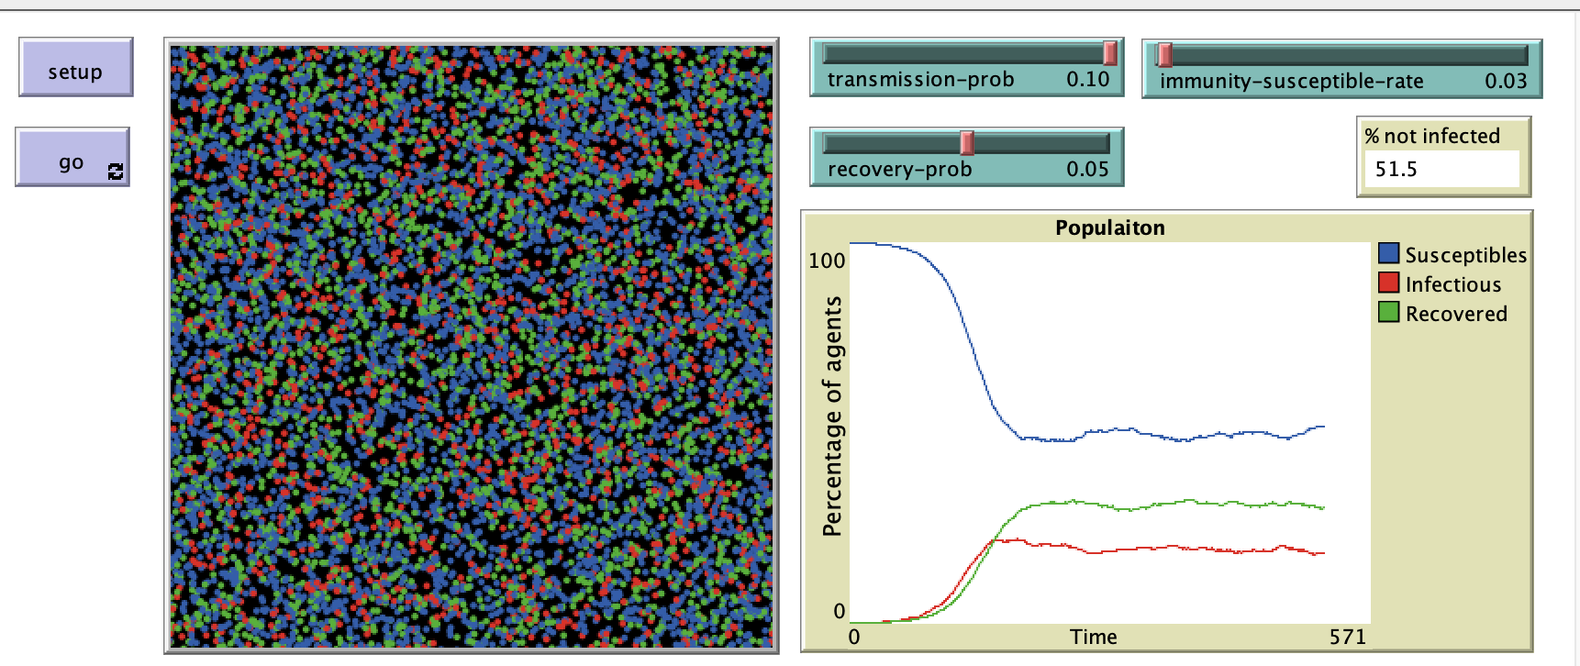

From the plot we can see recovered and infectious curve increases then stay the same

we can expect to see a more noticeable increase in the number of susceptible individuals over time post-recovery. The infection peak is lower than susceptible and broader compared to the first plot, reflecting a because they become susceptible again. Infectious rate becomes to rise but recovered rate begin to decrease compare to the plot before.

When immunity-susceptible-rate=0.05, we have the curve as below:

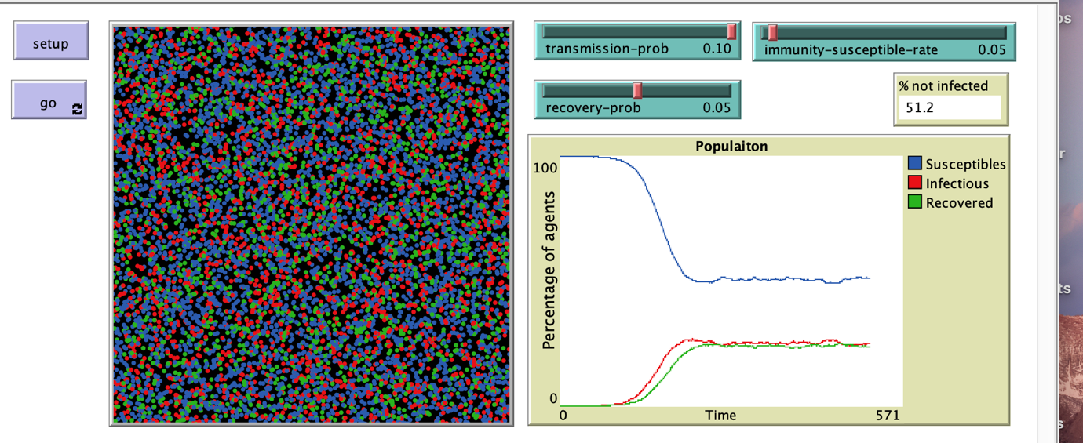

The graph shows a more pronounced fluctuations, with the number of susceptibles increasing more noticeably as the simulation progresses. The infectious peak is lower than before, infection curve exceeds the recovered curve due to higher immunity-susceptible-rate and recovered rate declines again.

When immunity-susceptible-rate=0.1, we have the curve as below:

The plots would show a substantial number of recovered individuals returning to the susceptibles. The infectious curve may not peak as sharply, reflecting a less distinct epidemic peak and a more protracted presence of the infection within the population. Recovered rate declines again.

When immunity-susceptible-rate=0.8, we have the curve as below:

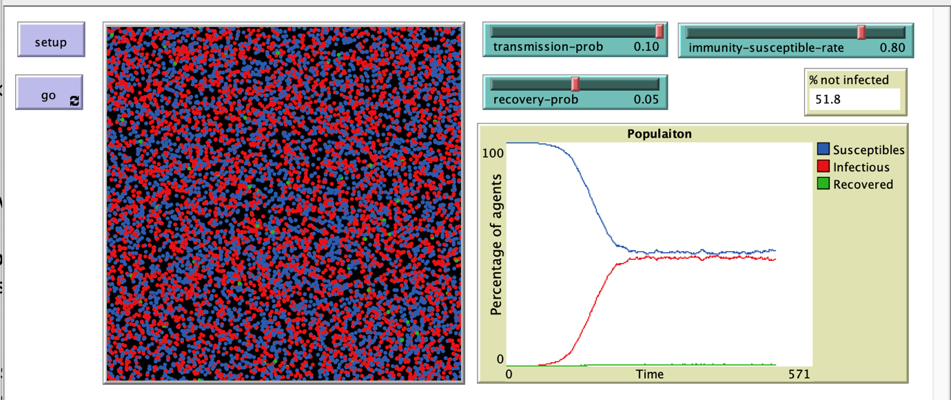

The plot shows the recovered curve is nearly zero illustrating nearly all recovered people become susceptible again every tick. The susceptible curve tends to be very close to infectious curve indicating the number of infectious and susceptible people are similar. "Herd immunity" might not be attainable as the population is unable to maintain enough recovered individuals with immunity.

Overall, we can see that as immunity-susceptible-rate increase, recovered rate reduce and susceptible rate and infectious rate increase.

**Q6:**

First, we need to set up the Behaviorspace. Set the immunity-susceptible-rate as the changing variable with value starting from 0 to 1 by 0.05. Then repeated the experiment for 50 times. The outputs are the susceptible rate, infectious rate, and recovery rate. The experiment is stopped when there are no turtles with infectious state. Set the time of steps to 500. The repeated times for the experimental could be set to 100 and the time limit could set to 5000 to get more precise result, because it needs long time to run so I just use smaller measure numbers. After the experiment finished, output the csv file. I renamed some of the variables for convenience to run in R that is saved in the excel file.

Plots are created to see how susceptible rate, infectious rate, and recovery rate changed with immunity-susceptible-rate. Firstly, see the plot of all values of susceptible rate, infectious rate, and recovery rate changed with immunity-susceptible-rate. The plot:

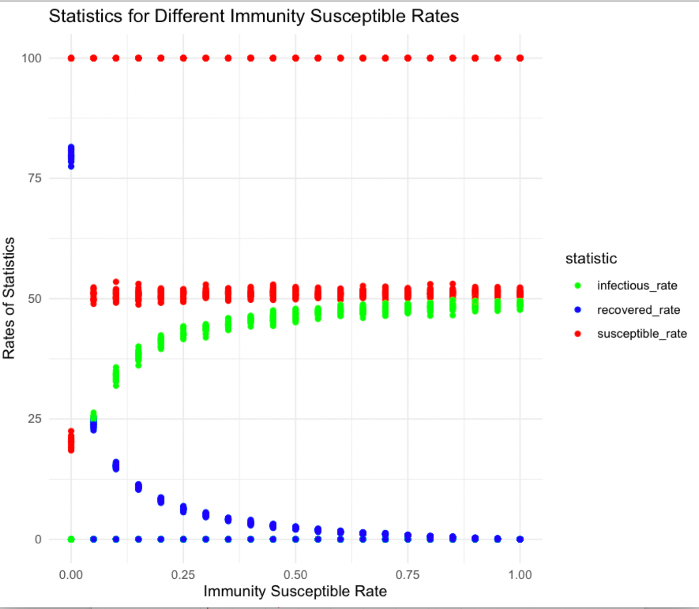

From the plot, it is obvious to see that susceptible rate appears to remain consistently around 50%. This implies that varying levels of immunity, most of the population remains susceptible.

The infectious rate shows an increased trend with a curve pattern. As the immunity susceptible rate increases, the infectious rate increases at first then reach at the similar value as susceptible rate- around 50%. The recovered rate decreases as immunity susceptible rate increases. Overall, susceptible rate is constant, so it does not associate with immunity susceptible rate, but recovered rate decrease with increasing in immunity susceptible rate and infectious increase with increasing in immunity susceptible rate.

Then calculated the mean values of susceptible rate, infectious rate, and recovery rate to produce the second plot. Plot the graph of each statistic vs immunity-susceptible-rate. Then use R to produce the plot. The R file is attached in the submission page. The final graph is shown below:

The plot illustrates that:

For mean Susceptible rate: When there is low immunity-susceptible-rate, the disease spreads quickly, but when immunity-susceptible-rate increase, the number of susceptible people first decreases then increase because more individuals are being susceptible again after recovering.

For mean Infectious rate: infectious rates among individuals shows variability across the immunity-susceptible-rates. Overall, infectious rate increases with the increasing of immunity-susceptible-rate.

Mean Recovered rate: Generally, the recovered rate decreases as the immunity-susceptible-rate increases. But it decreases more sharply with low immunity-susceptible-rate and more stable tends to zero with high immunity-susceptible-rate. This could suggest a threshold effect, beyond some point, more recovered people become susceptible.

Overall, we can see that recovered rate decreases as the immunity-susceptible-rate increases, but infectious rate and susceptible rate increase at first then fluctuated at a relatively fixed value range as the immunity-susceptible-rate rises.